FOR IMMEDIATE RELEASE
Chabad Lifeline Expanding Clinical Team to Meet Growing Demand 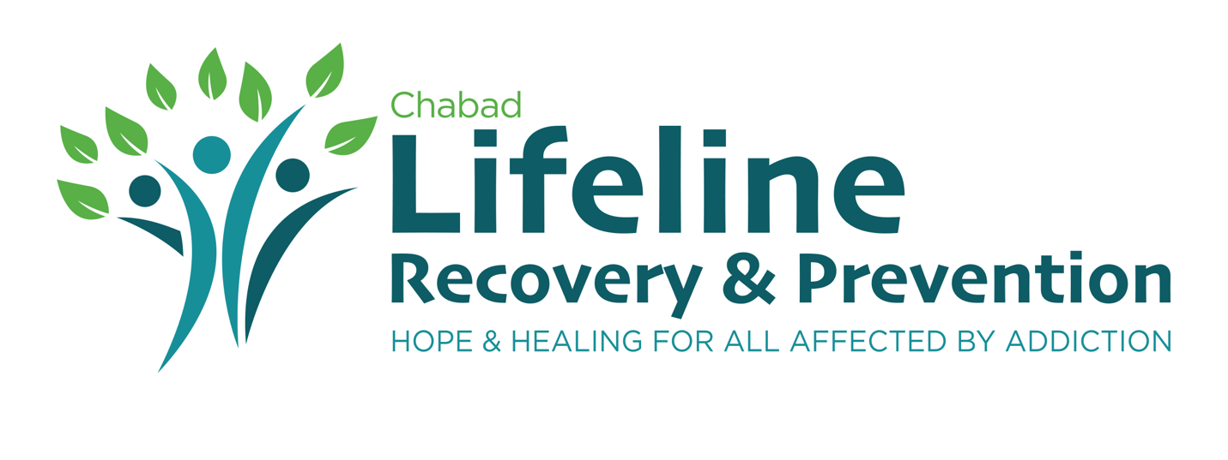Montreal, QC, January 29, 2024 – Chabad Lifeline, a leading non-sectarian agency committed to helping individuals, youth and families affected by addiction, is thrilled to announce the expansion of its clinical team in response to the increasing demand for its life-saving services. The organization is actively seeking qualified and passionate individuals to join the team, specifically for the roles of Client Care Coordinator/Certified Counsellor and Addictions Counsellor.
Chabad Lifeline's mission is to provide support to everyone affected by addiction, with a special focus on youth and families. The organization's commitment to guiding individuals and their families through the healing and recovery process is unwavering. Offering a comprehensive range of recovery options and a dedicated youth-at-risk program, Chabad Lifeline ensures immediate assistance for those in need, regardless of their financial circumstances.
Rabbi Benyamin Bresinger, the Director of Chabad Lifeline, emphasizes the organization's dedication to its mission: "The amazing work done by our clinical team means we now have a responsibility to help even more people. This is life and death, and we take it very seriously. We're seeking dedicated professionals who can further amplify our organization's impact in the community."
Qualified and passionate individuals are encouraged to visit the Hiring section of Lifeline’s website to learn more about the available positions and submit their applications. Chabad Lifeline invites the community to share the job descriptions with their networks, helping to spread the word about these opportunities.
For more information, please contact:

William Carney
Strategic Communications & Grant Coordinator
Chabad Lifeline
514-738-7700
Chabadlifeline.com
About Chabad Lifeline:
Chabad Lifeline is a non-sectarian agency dedicated to helping everyone affected by addiction, with a special focus on youth and families. People suffering from substance and behavioral addictions and their family members will be guided through the process of healing and recovery. Lifeline offers a full range of recovery options as well as a comprehensive youth at risk program. Its services are immediate, and no one is turned away due to financial circumstances.

